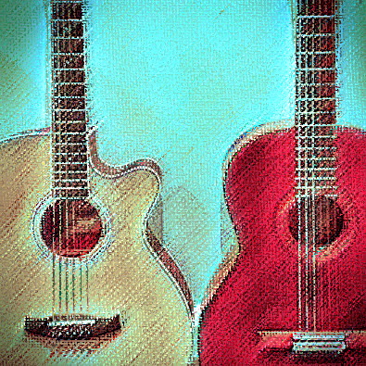

East Hunsbury Renaissance Blues

1 The Spanish Pavan
A shortened version of a 16th century lute duet by Italian composer Alfonso Ferrabosco. One instrument plays the main theme while the other plays variations over the top.

2 Bron-Yr-Aur
Composed by Jimmy Page of Led Zeppelin in 1970, though it didn’t surface until the Physical Graffiti album in 1975. A bit of echo added but the jingly sound is mostly due to the C-A-C-G-C-E tuning.

3 When the Levee Breaks
The original about the Mississippi flood of 1927 by Memphis Minnie and Kansas Joe McCoy. Led Zeppelin did a different, punchier version on their fourth album. In open A tuning (D-G-D-G-B-D with capo on second fret), played on a cheap ¾ classical guitar.

4 Ricercare no. 16
A free-form lute piece by another 16th century Italian, Francesco Canova da Milano.

5 Fotheringay
From the Fairport Convention album What We Did On Our Holidays, without vocals.

6 Mississippi Blues
A blues in A from the 1940s by one of three Willie Browns. Done with two guitar tracks. As here, often done without the singin’, man.

7 Quadro Pavin Galiard
Anonymous, from the 16th century. As the pavin (pavan or pavane, they weren’t too fussy about spelling) and galliard were dances in different timings, the title seems odd but means the galliard following the quadro pavin.

8 Blackbird
From the Beatles’ White Album. Paul McCartney wanted to emulate a Bach lute piece using counterpoint. It’s an anti-racist song (here without vocals) and not about a weird blackbird.

9 Passemeze and Passemeze Pavin
Another anonymous 16th century lute piece, or rather two pieces from separate sources fused into one. The passamezzo, or half-step, was a musical form with a set chord pattern.

10 Guitar Shuffle
By Big Bill Broonzy, from the 1950s. On ¾ guitar.

11 The Frog Galliard
By English Renaissance composer John Dowland. Apparently named after Francis, Duke of Anjou, who Elizabeth I called her frog (some think because he leapt around while dancing, others because he had a pock-marked face. Or maybe both). It was also an accompaniment to a song.

12 Black Mountain Side
Another Jimmy Page number, in D-A-D-G-A-D tuning, from the first Led Zeppelin album of 1969. Derived from Bert Jansch’s Black Waterside, which in turn was based on an Irish folk tune. Which in turn was no doubt based on something else. Maybe even a lute piece.

13 The Rain Song
From the 1973 Led Zeppelin album Houses of the Holy. The original is longer and has vocals. Folk and electric guitars.

14 Earl of Salisbury Blues
Taking liberties with Renaissance composer William Byrd's pavane.

A note on lute tuning
The Renaissance lute was tuned higher than a modern guitar. The tuning of the strings relative to one another is the same except that the third string is a semitone lower. To tune a guitar like a lute, turn the third string down from G to F#, then place a capo on the third fret, giving (from low to high) G-C-F-A-D-G.
Lute tuning makes 16th century tablature easier to read and makes playing in the keys favoured by Renaissance lutenists easier.

